INFO5995 Assignment 1
Task 3

Crypto API Analysis (No Vulnerability Found)

3.1 File Scope

Static analysis was performed across the application source code directory com/example/mastg_test0016 to identify the use of cryptographic APIs such as ‘MessageDigest’, ‘Cipher’, ‘AES’, ‘SHA’, and key-related classes.

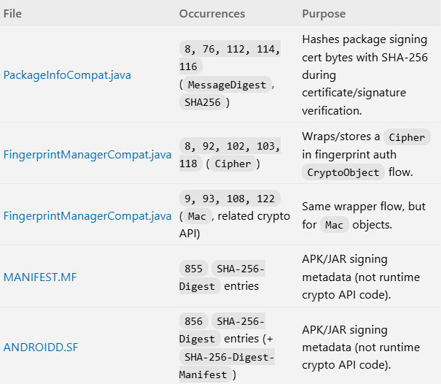

3.2 Findings

The search results show that occurrences of cryptographic APIs (e.g., MessageDigest with SHA-256 and Cipher usage) only appear in Android framework or support library classes, such as PackageInfoCompat.java and FingerprintManagerCompat.java. These belong to Android framework components and are not part of the application's business logic.

No usage of cryptographic APIs was found within the application’s core code (com.example.mastg_test0016).

3.3 Security Assessment

Since the application itself does not implement any cryptographic operations (e.g., hashing, encryption, or key management), there are:

- No weak hashing algorithms (e.g., MD5, SHA-1)
- No hardcoded cryptographic keys
- No insecure encryption modes

Therefore, no cryptographic misuse or vulnerability is identified in this direction.

3.4 Conclusion

This direction does not reveal any security-relevant vulnerabilities. The application does not implement cryptographic APIs within its own business logic, and therefore no cryptographic misuse is identified in this analysis.

